19-09-19

Python Learning :

Section 1 : Course Overview

Introduction:
OOP
Modules and packages
Methods and functions
Errors and all
Python 2 versus 3

Developed in 1991
Course FAQ

20-09-19
Section 2 : Python Setup
Command line basics
cd : change directory
dir : list of files and folders
cls : clear
D:/ then go to that drive

6. Installing the python
7. Running the Python code :
simple print

8.Getting the noteooks and all :
9. Git and Github :
Software is built then Github:

Section 3 : Python Objects and Data Structure

10 . Introduction to data :

Data types and Data Structures :

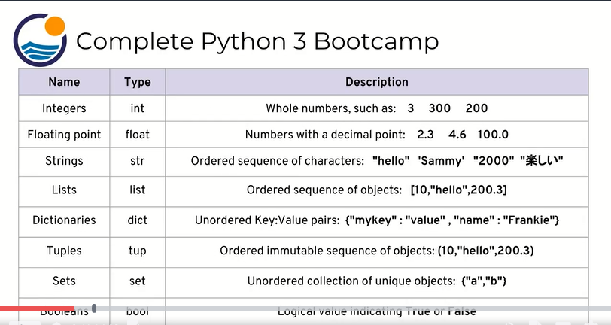

11. Introduction to Numbers :
Integers and Float

Addition 2+1
subraction 2-1
Multiplication 3*3
Division 3/2
7%5 Mod rim 2
2**3 : 8
2+10* 10+3=105
(2+10)*(10+3)=156

Exercise 1 : simple arithmetic :
Use one expression and ans is 100 :
ans.120-20
Difference between integers and float is decimal point
Quiz 1 Numbers

13. Variable Assignments :
python is dynamically type language
we can any data In one variable

Ex : a= 5
a o/p 5
a=10
o/p 10

type(a) then int o/p
a=30.1
type(a) then float o/p

14. Introduction to Strings :
Sequence of characters
‘’ or “”
Oredered and sequences [] slicing

Reverse -1 -2
Slicing : [start🛑step]

15. Indexing and Slicing with String :
Index : 1 character
Slicing : Grouping

Excercise 2 :Quick Print Check
print(“Hello World”)

16. Indexing and Slicing with String :

str="Company"
print(str)
print(str[2])
#indexing
print(str[-1])
#Slicing
print(str[1:6:2])
print(str[:2])
print(str[:2:-1])

O/p

Company
m
y
opn
Co
ynap

Coding Excercise 3 : String Indexing :
and Slicing :
“Hello World”[-3]
r
“tinker”[1:4]
ink

16. String Properties and methods :
str="Company"
s="K"
print(str)
print(str[2])
#indexing
print(str[-1])
#Slicing
print(str[1:6:2])
print(str[:2])
print(str[:2:-1])
#str[0]='K'
#print(str)
print(s+str)
print(str*2)
#method of strings
k='Ka ris hma Sala liya'
print(k.upper())
print(k.lower())
print(k.split())
print(k.split('a'))
print('Chips')
#String formatting
O/p
/usr/bin/python3.7 /home/karishma/strings.py
Company
m
y
opn
Co
ynap
KCompany
CompanyCompany
KA RIS HMA SALA LIYA
ka ris hma sala liya
['Ka', 'ris', 'hma', 'Sala', 'liya']
['K', ' ris hm', ' S', 'l', ' liy', '']
Chips

Strings FAQ
1. Are strings mutable?
Strings are not mutable! (meaning you can't use indexing to change individual elements of a string)
2. How do I create comments in my code?
You can use the hashtag # to create comments in your code

Install the ubuntu
Create the account in github

23-09-19

Section 2 to Section 5:

Strings : Formatting with strings with coding Exercise
2)List in python
3)Dictionaries in python
4)Tuples in python
5)Sets in python
6)Boolean in python
7)I/O with Basic File I/O
8)Python comparison Operators
9)Chaining comparison operators in python
10)Python Statements (If else, For Loops, While loop, Useful Operators,List comprehensions etc)
11)Methods and functions Overview(Running)

Section 6 : Methods and Functions :

Methods built in :

all the methods
docs.python.org //all the documents are available

Functions :Ability that not need to write the code again and again

